c. Pathway analysis
We additionally validated that the identified driver genes are active in biological pathways through a pathway analysis with the Kyoto Encyclopedia of Genes and Genomes (KEGG) (Ogata et al.); the identified putative driver genes across the four cancer types were shown to be active in pathways involved in cell development and apoptosis, including PI3K-AKT and Wnt/β-Catenin. (The full pathway is included in the Appendix.)
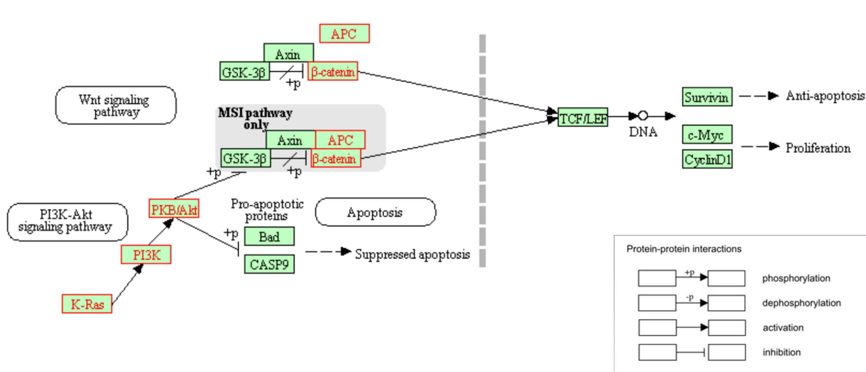Figure 3. Interaction pathway of select colorectal cancer driver genes identified by our classifier. The proteins typed in red are affiliated with genes identified by our classifier as a driver.

Phosphatidyl-inositol 3-kinase (PI3K) activity is associated with the transformation of viral oncoproteins; PI3K (encoded by PIK3CA, etc.) is central in several cellular processes, such as proliferation, growth, apoptosis, and cytoskeletal rearrangement. The primary consequence of PI3K activation is the generation of the second messenger PIP₃, which activates downstream pathways that involve proteins involving AKT and others. The phosphatase PTEN terminates the PI3K-AKT signaling pathway by dephosphorylating PIP₃ to PIP₂. Mutations on genes in the pathway --- PIK3CA, AKT1, and PTEN --- lead to aberrant pathway activation, and often, carcinogenesis. Our method is able to prioritize this signaling motif: lists of top ten driver genes for each of the four cancer types include at least two of these three PI3K pathway genes.
Another signaling pathway implicated in the driver genes returned by our method is the Wnt pathway. Signaling by the Wnt proteins via the transcription co-activator β-catenin controls embryonic development and adult homeostasis. β-catenin (encoded by CTNNB1) is regulated and destroyed by the beta-catenin destruction complex, and in particular by the adenomatous polyposis coli (APC) protein, encoded by the tumor-suppressing APC gene. The loss of negative Wnt signaling regulation by APC is responsible for around 15% of colorectal cancer cases.
We were able to construct a signaling pathway of colorectal cancer carcinogenesis based upon the list of predicted genes active in either the Wnt or PI3K pathway. Figure 3 is retrieved from KEGG as is a partial summary of the pathway. Products of the KRAS (driver score rank #3), PIK3CA (rank #5), AKT1 (rank #10), APC (rank #25), and CTNNB1 (rank #43) genes are depicted (Appendix).

